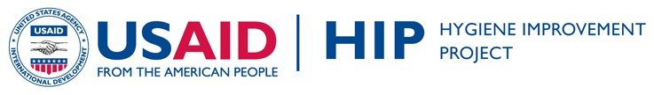
WASH & HIV/AIDS INTEGRATION:
TRAINING AND SUPPORT
HANDWASHING

The following handouts pertain only to handwashing and were developed as part of HIPs country programming in Uganda. They should be used to support the training of home-based care workers, in conjunction with the trainer’s manual for HBC from Uganda.

The entire training package from Uganda (with information all key WASH behaviors), including counseling cards, the participants’ guide and the trainer’s manual, are a part of HIP’s WASH HIV Integration Toolkit, which can be found at the following site: http://www.hip.watsan.net/page/4489. To access other program documents, such as research reports, please visit: http://www.hip.watsan.net/page/3586

Please note that because the following pieces were taken from a larger document and some sections have been removed, the numbering of the various sections matches the original document and is therefore not always consecutive.

TRAINING HANDOUTS: Handwashing

Improving Water,
Sanitation, and Hygiene
(WASH) Practices of
Uganda Home-Based
Care Providers, their
Clients, and Caregivers
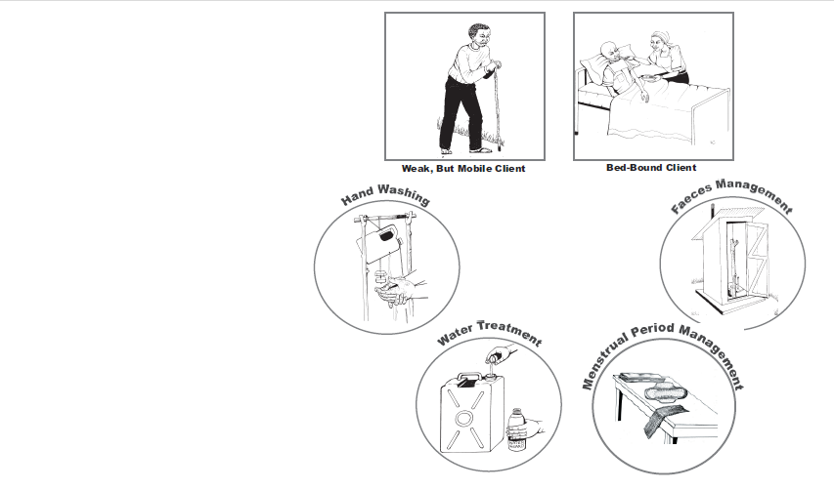
in the Home

The USAID Hygiene Improvement Project (HIP) is a six-year (2004-2009) project
funded by the USAID Bureau for Global Health, Office of Health, Infectious Diseases
and Nutrition, led by the Academy for Educational Development (contract # GHS-I-
00-04-00024-00) in partnership with ARD Inc., the IRC International Water and
Sanitation Centre in the Netherlands, and The Manoff Group. HIP aims to reduce
diarrheal disease prevalence through the promotion of key hygiene improvement
practices, such as hand washing with soap, safe disposal of feces, and safe storage
and treatment of drinking water at the household level.

Contact Information:  USAID Hygiene Improvement Project  Academy for Educational Development  1825 Connecticut Avenue, NW  Washington, DC 20009-5721  Tel. 202-884-8000; Fax: 202-884-8454  hip@aed.org - www.hip.watsan.net | Plan – Uganda  Plot 126 Luthuli Avenue, Bugolobi,  P.O. Box 12075  Kampala, Uganda  www.plan-international.org  Office Telephone: + 256-414-305-000

Handouts for Module 1, Session 1

Illustration on a Teaching and Learning Method

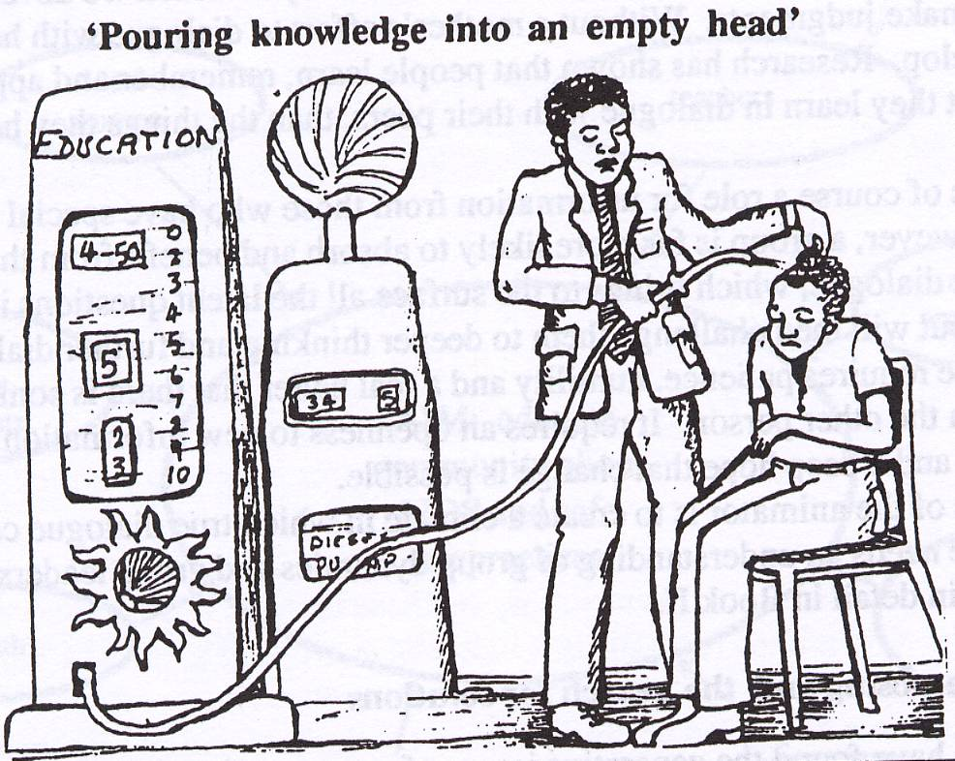

In this training, we do not want to just “pour” a lot of information into your heads without developing or using your skills in this course. We want you to be involved as much as you can in many exercises to help you learn and practice skills.

Training Objectives:
At the end of the training, HBC providers should be able to:
- Describe the role and responsibilities of an HBC provider in the provision of WASH care.
- Describe the four key water, sanitation, and hygiene (WASH) practices, including: treating, safely transporting, storing, and serving drinking water; safe handling and disposal of faeces; safe handling and disposal of menstrual blood; and hand washing with soap (or ash) and water and demonstrate actions required to implement the WASH practices in Home Based Care (HBC).
- Describe alternative methods of implementing the four key WASH practices and demonstrate the actions required to implement the practices.
- Assist HBC clients and their household members to adopt improved WASH practices.
- Demonstrate effective communication skills and steps needed to improve WASH practices, including use of the WASH assessment tools and Counselling Cards.

Handouts for Module 2, Session 2
What are HIV and AIDS?
H | Human: Only found in humans
I | Immuno-Deficiency: Weakens the immune system which is the body’s defence system
V | Virus: A type of germ

A | Acquired: To get, something not present at birth
I | Immune: The body’s defence system to fight illness
D | Deficiency: Lack of, or not enough of something
S | Syndrome: A collection of diseases, getting sick

Pictures of Joseph

Picture 1. This is a picture of Joseph, an HIV-positive client who is living with both HIV and AIDS. Joseph is living with both HIV and AIDS. HIV has beat up Joseph’s immune system, or his natural defence system, which should help to keep him healthy.

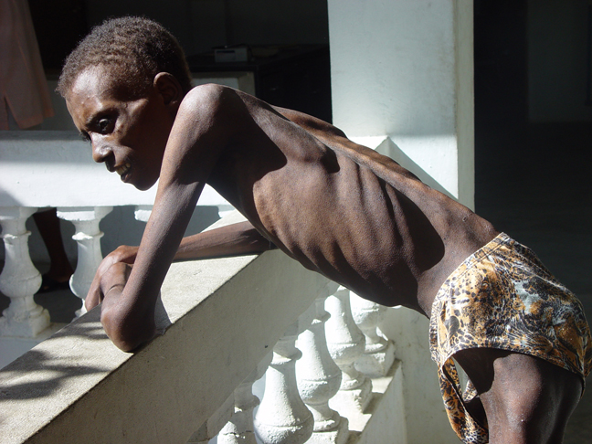
Source: Partners in Health

Picture 2. Joseph is feeling healthy and well. He is still living with HIV but his immune system is strong and he no longer is considered to have AIDS.

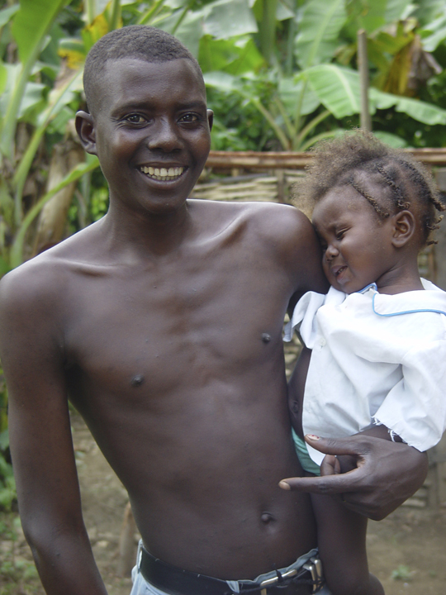
Source: Partners in Health
Picture 3: Importance of Keeping a Strong Immune System by Practising Good WASH Practices: Progression of HIV to AIDS
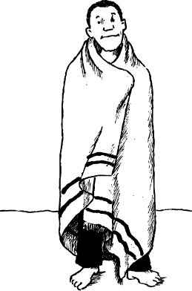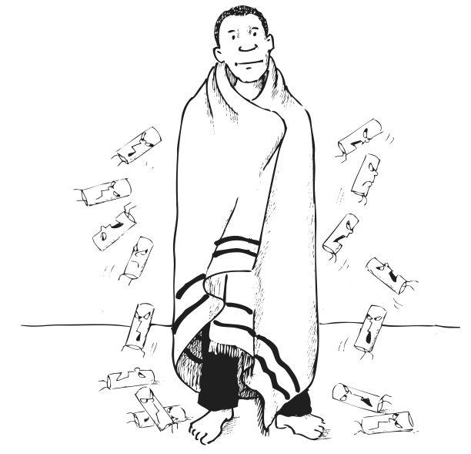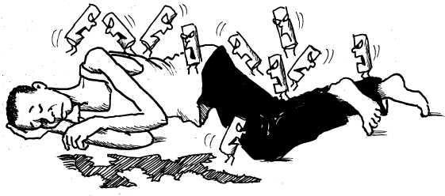
Image 1 Image 2 Image 3 Image 4
Picture Source: Partners in Health

Everyone has an immune system that fights off germs. Good water, sanitation and hygiene practices help keep our immune system healthy.
  - Image 1: Look at the first image. Think of the body’s normal immune system as a warm, protective blanket that fights off germs and keeps a person healthy and free from illness.
  - Image 2: Look at the second image. When HIV comes into the body, it begins to attack the immune system, much like a moth that starts to chew on a blanket but you cannot really see the hole. You can have HIV but not look or feel sick.
  - Image 3: In the third image, with no good care and with poor water, sanitation, and hygiene (e.g., drinking unsafe water, putting germs into your body with contaminated hands or food), HIV keeps destroying the immune system. The immune system can no longer fight off germs. Just like when a blanket gets holes in it, it cannot keep you warm. Without the immune system’s protection, it is easy to get sick with an illness or an “opportunistic infection.” This means that a weak immune system presents an "opportunity" for a germ to infect and cause a lot of unnecessary illness, including diarrhoea. This is one reason people living with HIV are more likely to have diarrhoea than people who are not living with HIV.
  - Image 4: Look at the fourth image. HIV has made the immune system so weak that it cannot work anymore. The warm, protective blanket that fought off the germs is now gone. This has now caused AIDS (Acquired Immune Deficiency Syndrome). At this stage, it is very easy for people living with AIDS to die of opportunistic infections. They actually die of the opportunistic infections that they get when they have AIDS, and they do not die from HIV.

How HIV Is Spread and Not Spread

Fluids that Have a HIGH RISK of Transmission of HIV | Fluids, Solids, or Things that Have a LOW RISK or NO RISK of Transmission of HIV | Three Main Modes of Transmission
- Blood, including menstrual blood  - Faeces with blood  - Vaginal fluids  - Semen  - Breast milk | - Faeces without blood  - Saliva  - Sweat  - Tears  - Mucous  - Urine  - Mosquitoes  - Sharing food, water or dishes  - Pets/animals | - Sexual intercourse  - Mother to child via: pregnancy, birth and breastfeeding  - Blood to blood contact (blood transfusions with untested blood, exchange of infected blood directly in a wound, sharing needles or other skin cutting/piercing instruments, knives, etc.)

Case Study 1: Identifying the Linkages between WASH and HIV

Case Study: Anne and Robert
Anne and Robert are a married couple living in Kampala. Robert got sick in 2001 and tested to be HIV-positive. A few years ago, Anne also became sick and was found to be HIV-positive. As Robert and Anne became weaker with HIV, they moved to Anne’s sister’s house. Anne’s sister, Florence, agreed to help take care of them until Robert and Anne became well enough to live on their own again. An HBC provider in Florence’s community eventually helped Robert and Anne get on ARVs at the clinic and provides them with support in the home. The HBC provider even provided them with a new jerrican for water and a bottle of the WaterGuard chlorine solution so they could treat their drinking water so it was safe to drink when taking their pills.
When Robert and Anne started filling their new jerrican at Florence’s neighbour’s water tap, they soon heard neighbours gossiping about them and whispering when they thought Anne and Robert weren’t looking. Robert and Anne knew the neighbours were talking poorly about them and they felt guilty and ashamed. The next door neighbour confronted Florence and asked if someone living with HIV was staying in the home. He said that visits from the HBC provider and the water container mean that someone with HIV must be living in the house. Very soon thereafter, the neighbour stopped sharing their water tap with the household. As a result, Florence had to cut back on the amount of food she could buy for the home in order for water to be bought and delivered to the house for cooking, drinking and other household needs. The family has also run out of WaterGuard solution and is unable to buy another bottle. They have started drinking local, untreated water.
The HBC provider has noticed on recent visits that Robert and Anne began to complain of frequent bouts of watery diarrhoea and weakness. When the HBC provider visited the home, there were many water containers (basins, jerricans and pots) which were scattered in the compound. Most water containers were very dirty and so was the water in them. The HBC provider also noticed that Robert was too weak to walk to the community latrine and had begun to defecate in the yard at night when neighbours were not likely to notice. The HBC provider also noticed that there was no soap or hand washing station in the home. When the HBC provider went with Robert to the clinic, they were told that Robert’s CD4 count had decreased since he had become so weak with the diarrhoea.
For the last couple of weeks, Anne has been feeling better. One day, she decided to surprise her sister by cleaning the house. When Florence returned from work, she was shocked to see that Anne was cleaning. She told Anne that she was too sick to be cleaning and she would prefer to clean her own house.

Pair Share
- Ask participants to think about the client in the case study and the household situation. Next, ask participants to turn to the person next to them to discuss and answer the following two questions on the flipchart:
Case Study Question 1: | What are the specific water, sanitation, and hygiene needs of Robert and Anne?
Case Study Question 2: | List at least two ways that the family was stigmatised because of Robert and Anne’s HIV status.

Definition of Home Based Care

Home based care (HBC ) is the total care of clients (including children, adolescents and adults) and their family members. It is care that is extended from the local health facility to the client’s home in partnership with the client’s family and community. It includes care for the client and family’s physical needs, psychological needs, spiritual needs and social support needs.

The Role of the Trained HBC Provider in Providing Water, Sanitation, and Hygiene (WASH) Care
- The HBC provider will improve their own practices in water, sanitation, and hygiene and will be a positive role model in the communities and households where they work.
- Working with their organisation and the households they serve, the HBC provider will continuously assess the needs of the client and the client’s household and determine where to start improving the client and the client’s household water, sanitation, and/or hygiene practices.
- The HBC provider will be responsible for conducting a wide variety of WASH activities in his/her community and households with a wide variety of audiences including individuals, families and groups. This means the HBC provider will use his/her skills and tools to focus on WASH in their home visits. The HBC provider also will demonstrate good WASH practices to household members and help clients and families improve their WASH practices over time.
- The HBC provider will assist households in advocating for and obtaining the supplies that will help them improve their WASH practices (e.g. soap or ash for hand washing, gloves or plastic material, etc). They will link and refer clients (and the clients’ households) to supplies and other resources that may be available in their communities or organisations.
- The HBC provider should be fluent in local languages of the community in which he/she works, as well as demonstrate excellent interpersonal communication skills and sensitivity to local practices and traditions.
- The HBC provider will monitor the WASH activities in the households he/she serves and keep records in accordance with the HBC provider’s organisation requirements. The HBC provider will use records to help track progress of the households as they improve their WASH practices.
- The HBC provider will work inside the program framework of his or her organisation and will help the organisation adapt and use the messages and tools from this WASH training to their local context.

Handouts for Module 3, Session 1

Definition of Small Doable Actions

When it is not possible to do the “ideal” behaviour, then:
- Small doable actions (SDA) are the small steps (‘baby steps’) or tasks that get you closer to the desired or ideal WASH behaviour.
- Small doable actions still improve the health of the individual or household (even if those actions are not as great an improvement as the “ideal behavior”).
- Small doable action are considered feasible (possible, realistic) by household members, from THEIR point of view, considering their current practice, available resources, and particular social context.
- Although small doable actions fall short of an “ideal practice,” they are more likely to be adopted by a broader number of households because they are considered feasible within the local context.

Handouts for Module 4, Session 2

Household Water Calculation Table
Water Calculation Table
Example for family of six
(including one infant, one toddler, two older children, one man who takes medication three times per day and is bedbound, and one woman who currently has her period)
EXAMPLE | Column “A”  Number of times a day/ each person | Column “B”  Number of family members doing this | Total number of times a day  (Multiply Column “A” with Column “B”)
After defecation | 2 | 3 (woman, 2 older children; the 2 babies don’t wash THEIR hands) | 6
After cleaning a client’s “private parts” | 4 (1 for defecation, 3 for urination) | 1 (ill bedbound man) | 4
After changing a nappie/diaper and cleaning a baby’s bottom | 6 | 2 | 12
After changing material used to absorb menstrual blood | 4 (menstrual period) | 1 | 4
Before preparing food/cooking | 3 | 2 (mother and daughter) | 6
Before taking/giving medication | 3 | 1 (father) | 3
Before eating | 3 | 4 | 12
Before feeding | 3 | 1(toddler that is eating solids) | 3
Before breastfeeding | 5 | 1 (baby that is still breast feeding) | 5
TOTAL |  |  | 55 TIMES A DAY

Handouts for Module 8

Practising Using the Assessment Tool, Counselling Cards, and the
4 A’s
Case Study: Anne and Robert’s Family
Anne and Robert are a married couple living in Kampala. They have been married since the year 2000, and were married when Anne was 18 years old. Anne did not complete her secondary schooling. Robert currently is unemployed and has a problem with drinking too much local beer.
Anne and Robert moved in with Anne’s sister, Florence. Anne stays at home to take care of Robert, Anne’s three children and Florence’s only child, a daughter, so there are four children living in the household. Anne also cooks for the family.
Florence is a teacher and uses her salary to take care of the family. The family lives in the Kisenyi slum area in urban Kampala, near a drainage channel where most people in the community defecate and dispose of faeces.
You are a home-based care provider in this community. Someone in the community told you that Anne and Robert are HIV-positive and that their family might need help. They also told you that the neighbours have complained about Robert coming home drunk late at night, hitting his wife, and screaming at her for not doing the things he told her to do.
You arranged to visit at a time that was convenient for the family. This is your first visit.

Hand Washing Situation
While in the home, you observe that:
You do not see any soap anywhere, nor do you see an established place for hand washing (like a hand-washing station). You notice that the household cooks with a saucepan and charcoal stove in the kitchen area where you see a katasa (small basin) with some grey, soapy-looking water.

Simulation: Helping People with Multiple WASH Needs
Birungi is an HBC worker who has been working with David’s household since last month. David was referred to Birungi by the community leader. Today Birungi visits David for the second time. During the first visit, Birungi noticed that David and his household have multiple WASH needs. Birungi decided to discuss and to negotiate the improvement of the household WASH practices on the second visit. After a nice introduction, Birungi carried out the assessment of WASH practices of the household with David.
The results of the assessment showed that:
  - Drinking water is stored in a jerrican without a cover and the jerrican is visibly dirty. David was given WaterGuard last month when he went to the hospital for his ART, but the empty bottle is lying on its side covered with dust and without the cap.
  - There is one shared latrine in the compound where David lives with his family. David’s wife does not like to be seen going to the latrine during the day and David said that the path to the latrine is very dirty and he prefers to practice open defecation discretely anywhere in the compound. David’s child, 5, uses the potty at night and practises open defecation during the day. There are faeces (animal and human) in the compound.
  - David buys two jerricans of water every day. He buys 3–4 jerricans once a week when his wife does the laundry. David has soap or ash at home all the time. David and his family wash their hands with water every morning, at noon, and before going to bed. David has an old 3 gallon jerrican at home.

Guiding Principles for HBC Providers to Negotiate Multiple WASH Needs
- Assessment
- Carry out a thorough assessment of all the WASH practices of the household
- Identify the WASH practices already being implemented and congratulate the client and recommend the client maintain these practices
- Identify the practices to be improved and the set of small doable actions to be negotiated
- Decision and selection of one WASH practice to be improved according to the following criteria:
- Availability of materials/supplies (higher probability for the family to implement)
- Approval of the head of household
- Negotiating the first improved WASH practice
- Negotiate only one behaviour at a time
- Follow up with the client until successful and consistent implementation and adoption of the improved WASH practice.
- Congratulate the client and ask him/her to continue to implement consistently the behaviour
- Negotiating the second WASH practice to be improved
- Check if the conditions are met for the second WASH practice to be negotiated – conditions include the availability of the materials/supplies and the approval of the head of the household
- Negotiate the improvement of the second WASH behaviour and follow up the implementation of the improved practice by the household
- Follow up the continuous and consistent implementation of the first improved WASH practice

Handouts Module 9: Self-Reflection Tool
Client’s Name: ________________________________________________
Self-assessment objective: To assess how well I am improving water, sanitation and hygiene practices during each household visit.
Instructions:
a. Write the client’s name in the space above.
b. | Read each question and place an “X” in the box that corresponds with your answer.
 | - I have yet to be successful
 | - Yes, I was successful
c. | For questions that were answered “I have yet to be successful,” think about how you can reach your objectives and discuss the problem  with your colleagues in your organisation or with your fellow HBC providers.
d. | Repeat the same process every time you visit the household.
QUESTIONS |  |  |  | MEETING 1 |  |  |  |  |  |  | MEETING 2 |  |  |  |  |  |  | MEETING 3 |  |  |  |  |  |  | MEETING 4
 |  |  |  | I have yet to be success-ful |  |  | Yes, I was success-ful |  |  |  | I have yet to be success-ful |  |  | Yes, I was success-ful |  |  |  | I have yet to be success-ful |  |  | Yes, I was success-ful |  |  |  | I have yet to be successful |  |  |  |  |  | Yes, I was  successful
1 | Did I help the family identify at least one practice (water treatment, hand washing, faeces care, or menstrual care) to improve?
2 | Did the family commit to trying at least one improved WASH practice?
3 | Did I ensure that all of the household members actively participated?
4 | Did I use the Assessment Tool to identify the current behaviours ?
5 | Did I use the Counselling Cards?
6 | Did I use the Assessment Tool and/or Counselling Cards to help the client/household members identify at least one improved behaviour to try?
7 | Did I write down the client’s current practice and new practice goals in my notebook?
8 | Did the clients and/or household members ask questions?
9 | Did I set up a day and time for my next household visits?

